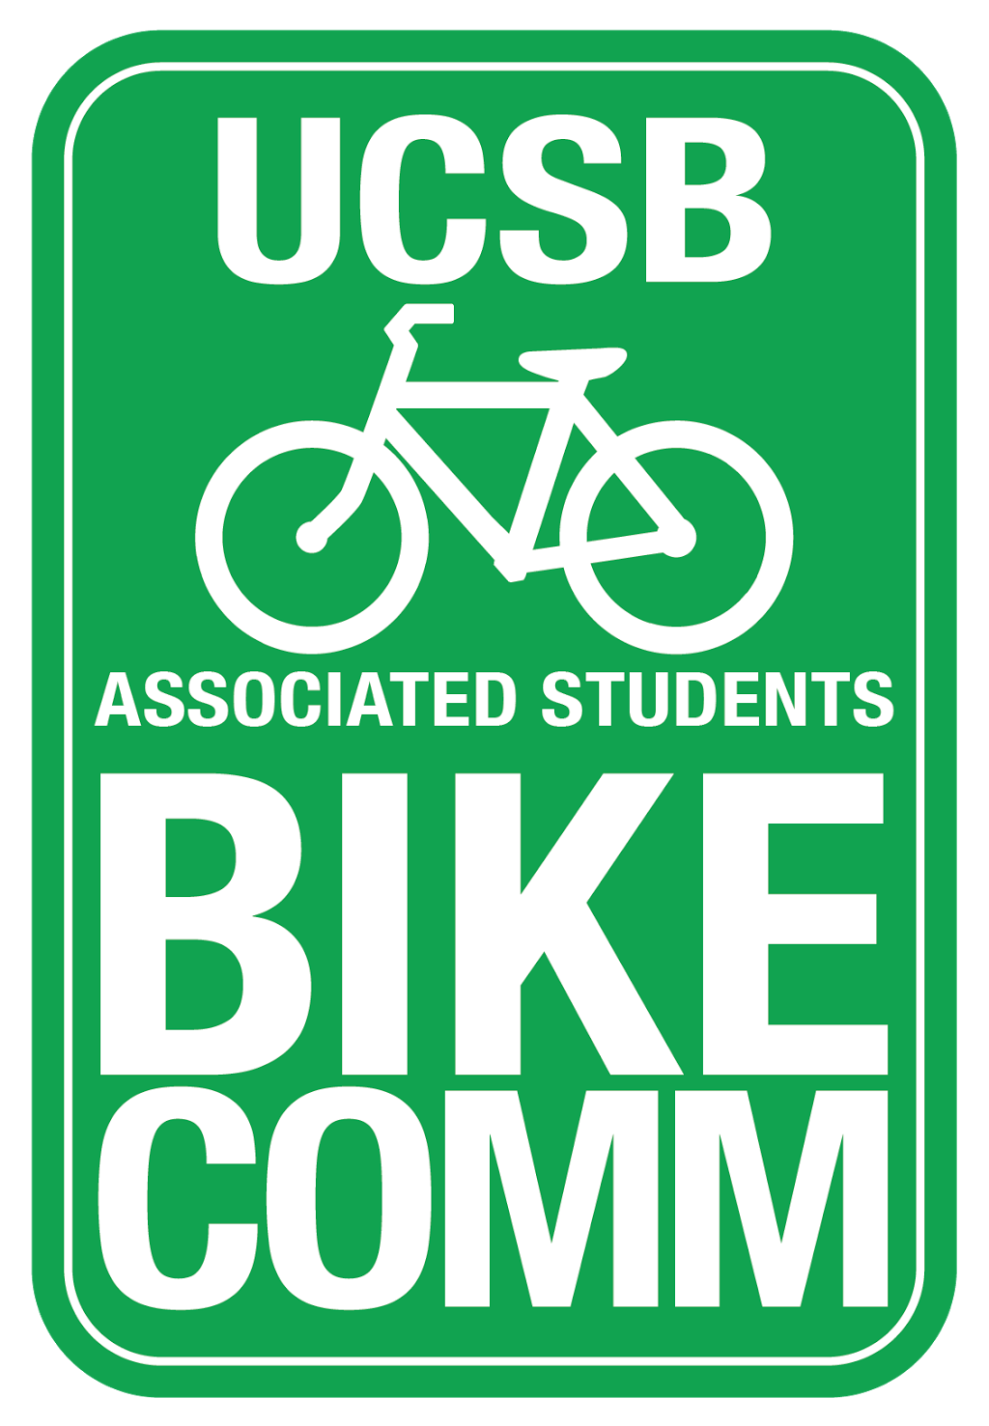
Bike Committee Weekly Meeting Agenda

Associated Students
November 2, 2016 3:30pm
Bike Committee Office

CALL TO ORDER 3:35

A. MEETING BUSINESS
- Roll Call

Name | Note:  absent (excused/not excused)  arrived late (time)  departed early (time)  proxy (full name) | Name | Note:  absent (excused/not excused)  arrived late (time)  departed early (time)  proxy (full name)
Kevin Jin  Chair | Present | Eric Boessenecker  Educational Officer | Absent (not excused)
Annie Golay  Vice Chair | Present | Angela Ho  Associate Officer | Present
Tiffany Yeh  Project Manager | Present | Daniel Kolosta  Associate Officer | Present
Rohan Malpure  Finance Manager | Present | Ngoc Hoang  Associate Officer | Present
Lianna Nakashima  Media Coordinator | Present | Navpreet Khabra  Associate Officer | Late (3:42pm)
Jorge Sandoval  Admin Coordinator | Present | Sarah Siedschlag  Advisor | Present

- Acceptance of Excused Absences and Proxies
MOTION/SECOND: Jin/Golay
Motion to accept excused absences and proxies
ACTION: Vote: Consent

B. PUBLIC FORUM
  - General Announcements
  - Appreciations/Concerns
  - Request to have item added to today’s agenda

B. Committee Business

D. REPORTS
- Advisor Report
- Associate Officer(s) Report
- Administrative Officer Report
  - Using google docs for minutes
    - For senate, send as a pdf/word doc
- Education Officer Report
- Project Manager Report
- Media Coordinator Report
- Finance Manager Report
- Vice-Chair Report
  - Climate Coalition meeting Ellison 3621 1-2pm on Friday
    - Sarah will go, Annie will try to go
- Chair Report
  - Got data from bike thefts from IV Foot Patrol
  - Working with a CompSci major to make a presentation of the data
  - Also, a Senator has brought up an idea to make a bike rental program for Isla Vista
    - Nakashima wants to know what we are going to do about bikes that never get removed and are probably abandoned by Isla Vista
    - Bike abatement will probably resume in Winter once CSO’s will be done training

E. Old Business

F. New Business

- South Hall New Parking lot on North West Corner
  - Proposal of $12,134.54
    - We should add 10% more for extra room in case of extra expenditures
  - Quote for Peak Racks
  - There will be a plaque on the bike rack that will be coming with it
  - 141 new bike slots
MOTION/SECOND: Jin/Golay

Motion to allocate up to $13,000 for the installation of 141 bike parking spaces and plaque at South Hall on the North West corner.

ACTION: Vote: Consent

- Stickers
MOTION/SECOND: Jin/Golay
Motion to approve an additional $300 for stickers with new design and size dimensions
ACTION: Vote: Consent

G. DISCUSSION ITEMS

- Bike N’ Blast Recap
  - Bike Gripe: The Return
    - There are already a lot of fliers with the name bike gripe
    - Golay: The other names were not as good
    - We are sticking to bike n blast
  - Students generally agree with our ideas about bike related issues
    - Campbell needs more bike racks
    - New lecture hall will bring up more issues and we don’t have much input
  - We want a digital representation to show our resuts of the bike n’ blast event
  - Suggestions were mainly to widen bike paths, fix pot holes, add more bike parking.
    - Main bike path suggestions were in regards to music hall bike path and the UCEN
    - HSSB and Music hall Bike Path need more lights
    - People like more peak racks because they feel safer.
    - Khabra: we should put more lights towards Chem and near Bren Hall
    - Golay: we also need more lights by San Clemente
      - Public Safety Commission could also help us even though they mostly do lighting in IV.
  - The event went well but we need to get better to engage people, could give out shirts. We need to coordinate amongst ourselves
    - We should do shifts next time
  - Bike N blast next quarter
    - Couple of days trying to get info instead of just one day
- Bike Auction
  - Week 3
  - Khabra- auction was slow because people were slow in choosing bikes and there wasn’t enough CSOs to keep the auction going fast.
    - Bike Comm can answer questions and CSOs can do the administrative work
    - CSOs were kind of confused too so that threw people off
    - Jin: we can do something online
      - Take a picture of the bikes and post them online and they could choose what they want
      - CSOs should get Bike Comm more involved
        - CSOs handed out tickets way before the event started and it was not fair to students who came at the time it started
  - Online auction would be kind of tough because people like to touch the bike and “try” it before buying
  - We should have the bike auction closed off to make it easier to organize people and bikes and preventing people who didn’t get in line go into the lot
  - Bike Auction advertising needs to be done week 1
- Future Events
  - We should have bike n blast in week 3
    - Maybe we can have it during the auction so while people stand in like they can Bike n’ Bast
    - Storke gets too crowded but now that we don’t have the full fair we can have it at storke as opposed to the srb lawn which was where the fair is
      - Tires and bikes could damage the lawn so we could have it on the storke tower where the cement is
      - We could also rent out storke plaza
  - We should do something with COSWB
    - We can do it around week 7
    - Ride around campus or near here
      - We could ride to Goleta beach and have something there.
        - Mountain biking or ride to the beach
        - They partner with blenders
        - BIKE N’ BLENDERS
    - Annie could come up with ideas and we could go to their meeting and present their ideas
  - Ride And Ramen
    - WEEK 4 Saturday at 1pm at
    - We could make bike safety “passes” for the RAs to hand out and put in the dorms
  - CycleMAYnia is coming up and we could be a part of it.
- Stickers
  - We could make the stickers either rectangle or square

ADJOURNMENT

MOTION/SECOND: Jin/Golay
Motion to adjourn the meeting 4:40
ACTION: Vote: Consent

